1. **Executive Summary**

**1.1 Project Overview**

This is part 2 of the Robot Triathlon project called “Agility”. This includes making the robot go through a course designed to look like a figure 8, 5 times and blink 5 different colors then finish with speaking “I am the winner”. This project is to test our team’s ability to manage and code our robot for the Agility test.

**1.2 Purpose and Scope of this Specification**

The Sphero robot needs to path and complete a figure 8 track with the ability to blink 5 times after the course is over and say “I am the winner”.

1. **Product / Service Description**

**2.1 Product Context**

The product of our team’s work to generate and code a four part system of tests for the robot. First Endurance, then Agility, Then Accuracy.

**2.2 User Characteristics**

This product will be used by our team of students on each of the upcoming robotic tests.

**2.3 Assumptions**

* The code will work on the first or second try
* The room will be available for use
* Everybody will contribute their part and get their jobs done correctly and on time
* Robot will have no issues

**2.4 Constraints**

* Room not being available
* Coding errors
* Floor being made with tiles
* Very hard to have friction which creates pathing errors for the robot
* Not too much time to work on this
* Robot taking long to charge

**2.5 Dependencies**

The sphero will require a charger and also proper coding to perform well on the Agility track.

**3.** **Requirements**

The robot will need to traverse a line that resembles the shape of a figure 8 and change colors at the end of the Agility test. The robot will also need to speak at the end of the test before going offline.

**Priority Definitions**

* Priority 1: The robot MUST trace the outline of the figure 8 and change colors at the end of the test; The robot will also need to speak at the end of the test.
* Priority 2: The robot will need to have multiple attempts to get the correct path at the start of the test to have the most accurate pathing.
* Priority 3: A “nice to have” feature would be to have a way to align the robot correctly every time without multiple attempts to get the best and most accurate pathing.

**3.1 Functional Requirements**

|  |  |  |  |  |  |
| --- | --- | --- | --- | --- | --- |
| **Req#** | **Requirement** | **Comments** | **Priority** | **Date Rvwd** | **SME Reviewed / Approved** |
| **ACCUR_1** | **Must be able to perform a perfect figure 8 and repeat 5 times.** | **This was challenging because the floors were tile which provided little friction.** | **1** | **11/14/22** | **Approved** |
| **ACCUR_2** | **Needed to flash multiple colours after performing figure 8 for 5 seconds.** | **We used a loop and delay to get a nice color pop that lasted 5 seconds.** | **2** | **11/14/22** | **Approved** |
| **ACCUR_3** | **Needs to speak after completion and say “I am the winner”** | **This was just a simple speak command** | **3** | **11/14/22** | **Approved** |
|  |  |  |  |  |  |

**3.2 Security**

**We used a password to get into the sphero account**

**3.2.1 Protection**

To protect the robot’s code integrity we would use a private connection that would need an admin password to get approval to operate the robot. The robot will also have an activity log that would show the user’s ip address and location of the device that was used to activate and use the robot. We would also have at least 2 approved admins on set to watch the robot be used. The robot will also have constant data logging to make sure if anything goes wrong that there will be data to find out where the error occurred.

**3.2.2 Authorization and Authentication**

We would use PubCookie to authenticate users and grant them access.

**4. Requirements Confirmation / Stakeholder Sign-Off**

|  |  |  |
| --- | --- | --- |
| Meeting Date | Attendees | Comments |
| November 14th, 2022 | Richard K, Roman D, Shabbar S | After as few errors we were able to get the robot to successfully and accurately complete its tasks. |

**5. System Design**

**5.1 Algorithm**

Accuracy Algorithm

1. Start robot

2. Align so it will move along allotted path

3. Stabilize

4. Set the speed to 59

5. Spin 360 degrees for 8.5 seconds

6. Spin -360 degrees for 8.5 seconds

7. Repeat steps 2 through 6 five times

8. Stop

9. Change color to red

10. Delay .5 seconds

11. Change color to Blue

12. Delay .5 seconds

13. Change color to Green

14. Delay .5 seconds

15. Change color to purple

16. Delay .5 seconds

17. Change color to light blue

18. Delay for .5 seconds

19. Repeat steps 9 through 18 two times

20. Speak “I am the winner” and wait

21. Exit the program

**5.2 System Flow**

**file:///C:/Users/radat/OneDrive/Desktop/Accuracy.drawio.pdf**

**5.3 Software**

We used the Sphero box coding and api to code the robot.

**5.4 Hardware**

We used the Sphero given to us and the blue tape shaped in a box in the CS room.

**5.5 Test Plan**

|  |  |  |  |  |  |
| --- | --- | --- | --- | --- | --- |
| **Reasons for Test Case** | **Test Date** | **Expected Output** | **Observed Output** | **Staff Name** | **Pass / Fail** |
| **First test to get the robot on the correct path** | **11/14** | **The robot would follow the first circle** | **Robot made it around the first circle successfully and accurately** | **Richard k, Roman D, Shabbar S** | **Passed the first time** |
| **Test to get the robot to pivot** | **11/14** | **Robot would make it around the second loop accurately** | **Robot would make it around the second loop a little less accurately** | **Richard k, Roman D, Shabbar S** | **Failed several times but was able to successfully get around the circle a little less accurately then the first circle but it was good enough** |
| **Test to get the robot to follow the shorter line** | **11/14** | **Robot would get around each circle 5 times** | **Robot would stray off line but was fixed** | **Richard k, Roman D, Shabbar S** | **Failed twice then was able to pass** |
| **Test to get the robot to finish the course** | **11/14** | **Robot would go around each circle 5 times, then change colors 5 times, and speak “I am the winner”** | **The robot strayed off the line but after re-aligning would make it through without any problems successfully and changed colors with speaking at the end successfully.** | **Richard k, Roman D, Shabbar S** | **Failed several times due to inaccuracy on putting the robot down but then was able to pass** |
|  |  |  |  |  |  |

**5.6 Gantt Chart**



**5.7 Staffing Plan**

|  |  |  |  |
| --- | --- | --- | --- |
| **Name** | **Role** | **Responsibility** | **Reports to** |
| **Richard** | **Writer/Designer** | **Filling info for design** | **Each other** |
| **Shabbar** | **Coder/Designer** | **Coding/Algo/FLchart** | **Each other** |
| **Roman** | **Manager/Designer** | **Helping with a bit of everything** | **Each other** |

**Block Code**

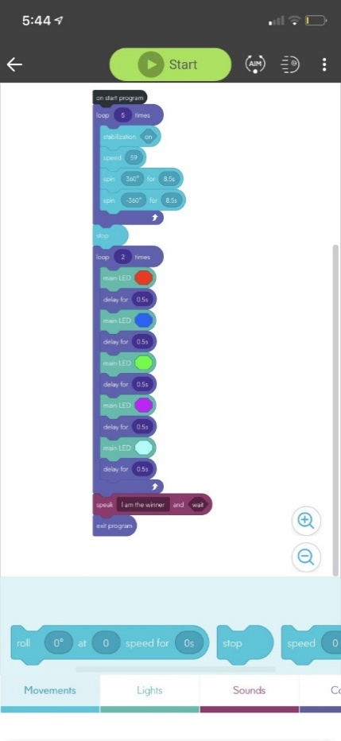

**Sensor Data**

